Jakob Werle

Temple University | Fall 2023

Laboratory Testing Methods for Improving Vehicle Performance

tECHNICAL cOMMUNICATION

**DRAFT**

**2024-12-08**

Abstract

This project compares full vehicle laboratory test methods for improving the suspension setup process in road racing. Three candidate solutions were analyzed: 4-Post Shaker Rigs, 7-Post Shaker Rigs, and Kinematics and Compliance Testing Rigs. Each solution was assessed on its setup requirements, acceptable vehicle range, and effectiveness of test results.

# Executive Summary

Table of Contents

Executive Summary 1

Problem Analysis 4

Overview of problem and its significance 4

STEM fundamentals of problem 4

Lessons from prior responses to the problem 5

Project objectives and constraints 6

Candidate Solutions 7

Scope of solutions considered 7

Track testing 7

Computer simulation 8

Shock dynamometer 8

Explanation of candidate solutions 10

4 Post Shaker Rig 10

7 Post Shaker Rig 10

Kinematics and Compliance Testing 10

Comparative assessment of candidate solutions 10

Project Recommendations 12

Proposed solution 12

Design and implementation challenges 12

Anticipated project outcomes and impacts 12

Glossary 13

References 14

Additional sources consulted 14

List of Figures

Figure 1: Suspension System 5

Figure 2: Penske S-Link PHD-2 Shock Dynamometer (Penske Racing Shocks, n.d.) 8

Figure 3: Shock dyno plot - Comparing damper adjustments (Courtesy of Temple Formula Racing) 9

Figure 4: How to read a dyno plot (Penske Racing Shocks, n.d.) 9

Figure 5: 4-Post Shaker Rig Layout (Bennett, 2012) 11

Figure 6: 4-Post Shaker Rig Top View (Bennett, 2012) 12

Figure 7: 7-Post Shaker Rig Setup 13

Figure 8: Kinematic testing simulator (Dodds & Plummer, 2001) 14

List of Tables

Table 1: Potential Suspension Setup Options (Boggs, 2009) 6

Table 2: Comparison of Candidate Solutions 14

# Problem Analysis

## Overview of problem and its significance

The basic goal of motorsport is for one driver and vehicle to negotiate a fixed distance faster than any other competitor (Smith, 1978). Drivers must manage varying track surface conditions, weather, traffic, the weight of fuel burning. Typically racing events are a combination of practice, qualifying, and racing sessions. The purpose of practice sessions is for drivers and teams to become acclimated with the new track and fine tune the vehicle’s setup package. Practice sessions are extremely valuable to racing teams as these are usually the only times that teams are willing to experiment. For series like Formula 1, teams are only granted two extra testing days throughout the entire season. Qualifying sessions see race cars outfitted in their fastest setup package, as their fastest lap time will designate in what place it will begin the race. Usually, race durations can vary from 15 minute sprints to 24 hour endurance formats. Either way, the race setup will be such that the vehicle is consistently drivable, has minimal tire wear, and is fuel efficient.

As testing time is limited, the methods used to dial in a vehicles’ setup has become increasingly important. Racecar Engineering magazine suggests that for teams to be competitive they have to take advantage of simulation tools (Segers, 2014). Improvements in technology have allowed the race car to be analyzed before it ever touches pavement. Suspension setup, in particular, is hypersensitive to specific drivers and tracks. An effective solution will allow racing teams to develop the most complete setup package for their car before arriving to the race track so they can be competitive.

## STEM fundamentals of problem

The concept of tuning begins with the understanding that a race car is simply four tires and a driver outfitted with devices that allow it to negotiate a track as fast as possible. Changing the configuration of any devices in the correct way can aid the driver in driving the track faster and more efficiently. The most critical of the devices begins with tires. Tires receive all road inputs and generate all tractive forces, as they are the only parts of the car in contact with the road surface(Smith, 1978). Therefore, racecar tires are sensitive to variations in loading and relative position to the ground (Smith, 1978).

There are two modes in which tires interact with the vehicle to produce traction – mechanically and aerodynamically. Mechanical grip is the result of the kinematic design of vehicle and setup of suspension components. Typical race cars have some form linkage that connects the wheels to the chassis. A spring and damper assembly allows the wheels to absorb bumps and just as importantly, control the motion of the chassis. Aerodynamic grip, which is produced by wings and bodywork, takes affect at higher speeds and is dependent on vehicle ride height and attitude.

Many of a vehicles dynamic parameters are designed directly into the chassis with regulations, packaging, and tire allocation in mind. This can make fundamental characteristics of a car challenging to adjust because large weldments and assemblies would need redesigned. Several parameters of racecar have been designed into a window of operation and have corresponding mechanical adjustments that can be made by a technician. The number and type of adjustments available varies with the type of car, typically with more complex systems found at higher levels of racing. Figure 1 displays a 3D rendering of the suspension linkages and wheel assemblies for the University of Padua’s Formula Student car.

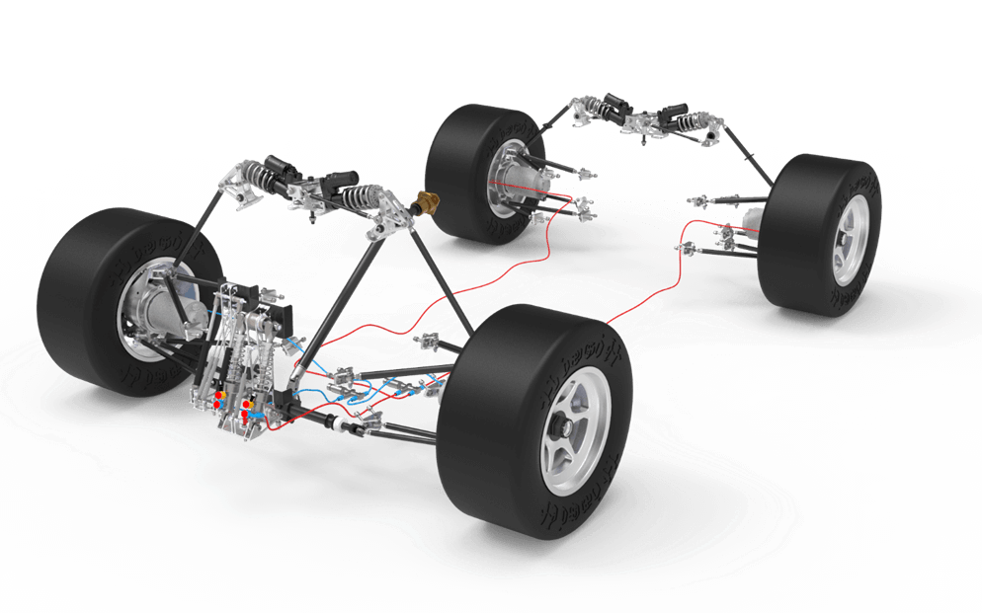

Figure : Suspension System

What do dynamic tests yield for results? How are cars fine-tuned?

Gathering data for vehicle systems comes in a variety of methods but it always is focused on analyzing a particular metric. With that being said, most testing utilizes a variety of equipment. Most of the time the metric boils down to measuring a force, position, or acceleration of components. There are many ways to capture each vehicle parameter. For example, tire loads can be collected using load cells while driving or by monitoring feedback loop data from shaker rig posts.

Since one goal of improving suspension performance is minimizing wheel load divergence (insert citation), the data gathered needs to organized appropriately. It is widely understood that minimizing normal load variation of each tire will result in better vehicle handling (Kelly et al., 2002). Since more downforce is created at lower ride height, having better control of the vehicle’s platform is critical (Kelly et al., 2002). Being able to run the vehicle as low as possible without upsetting the chassis and suspension will allow the most traction to be extracted from the tires, resulting in the most performance.

In a paper by wrote by Vanhees and Maes, the vibration behavior of a vehicle is broken into three main groups (G & M, 2002). Frequencies between 0-25 Hz are attributed to handling and ride, the 0-100 Hz range is for harshness and comfort, and the 50-10000 Hz range is concerned with vibrations that affect structural integrity (G & M, 2002).

## Lessons from prior responses to the problem

* What things have been successful in testing
* What problems have persisted since beginning solutions
* What ideas from a range of solutions could be helpful to continue using?
  + Ex. Simulated damper sweeps in 4 post rig could be used in K&C
* Infrastructure challenges from building rigs
  + Expensive
  + Need engineers to work the machines
  + Lots of machines and concrete
  + Locations – racing teams are worldwide
* Where testing has been conducted and lack of data
  + Racing teams secrete equipment and data
  + Few locations

## Project objectives and constraints

The goal of this project is to analyze existing forms of dynamic vehicle testing and suggest methods that will yield the most effective improvements to vehicle performance. It is explained that successful testing results are able to provide a variety of setup changes that would benefit the vehicle (“Seven-Post Rigs,” n.d.). Since racing events take place in ever changing conditions, being able to have options for vehicle behavior is beneficial. Good data is able to help an engineer draw correlations between parameters that might not have been seen without testing. Also it can narrow the window of what is understood to be suboptimal setup choices.

Another aspect of selecting a testing method is determining the type and quantity of data points to be analyzed. Due to the decreasing costs of electronics and growth of technology, adding data acquisition to vehicles and testing apparatuses has become very accessible (Segers, 2014). Engineers can quickly add enough sensors to swamp the data logging system. In addition, the number of setup options can become overwhelming. As seen in Table 1, for even a fairly standard vehicle package, the number of individual adjustments is significant (Boggs, 2009).

Table : Potential Suspension Setup Options (Boggs, 2009)

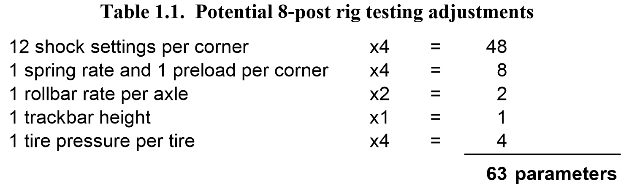It is desirable for the analysis to be efficient which requires the least amount of time between testing and results.

Ideally, using simulation testing tools decreases the cost for a racing team to be successful. Unfortunately, this reality is not feasible because the inevitable costs associated with more testing.

For a given series, the competitors will be made aware of what tracks they will race at far in advance. Since a unique setup is desirable for each track, simulation testing would be conducted for each racing event.

# Candidate Solutions

## Scope of Solutions Considered

### Track Testing

The most fundamental form of tuning the race car is track side tuning. While track tuning does not take advantage of engineering tools and extra time found in a lab, it is worth understanding the most fundamental approach. Furthermore, for all methods that will be analyzed, track tuning will be remain as one the last steps in validating a setup adjustment.

A typical track tuning session consists of shaking down the car and running through a testing plan. The shake down is an essential step in which the car and driver are introduced to the new track. A testing plan is developed before the testing day and targets a particular segment of the vehicle. As progress is made with the vehicle’s performance, the testing plan can be adjusted to target more vital aspects of vehicle’s handling. Because adjustment decisions are made based on analyzing vehicle data and driver feedback after each session, the duration of the testing process can be lengthy.

Major benefits of track tuning are that the car will be in virtually the same environment as when it will compete. On a similar note, the vehicle’s components will respond to track stimuli in their natural way, which is something that is needs to be accounted for when putting the car on various testing rigs. The level at which testing is done comes down to the data acquisition system fitted to the vehicle and efficiency of the crew. A simple data system can cost hundreds to thousands of dollars. For lower levels of racing, the performance gain of a data system can be negligible without a track side engineer, which can significantly increase costs. Weather also needs to be factored in to a testing plan, as rain or accidents can have major effects on scheduling and performance results. Performance analysis is also limited to the vehicle’s data logging system, as the number and type of sensors used depends on the system’s available inputs. Custom logging systems allow full customization of data acquisition, but are typically found at higher levels of racing due to increased cost and development.

### Computer Simulation

An alternative to testing the actual vehicle is using software to simulate performance. There are many forms of simulation that allow a racing team to develop up to 99% of the car’s setup (Segers, 2014). The two main forms of simulation are Kinematic Simulation, where a car’s suspension geometry is analyzed inside software, and Lap-time Simulation, where a mathematic model of the car is used to determine the effects of various setup changes. Both forms of software simulation allow parameters of the vehicle to be tested without going to the race track (Segers, 2014).

The effectiveness of computer simulation is often associated with how detailed and complex the model of the vehicle is (Segers, 2014). To properly setup a kinematics model, the three dimensional locations of all points which suspension linkages articulate about, called “pick-up points”, must be known. Typically, finding pick-up points involves disassembling the vehicle and measuring each component to a high precision. This process can be complex due to the need for fixturing components and creating datums to take measurements from.

### Component Level Vehicle Testing

The next logical step for racing engineers is to imperially test vehicles and their components in a laboratory setting.

A shock dynamometer, or “shock dyno” for short, is an instrument used to quantify the damping characteristics of a race car damper. Using a shock dyno can be useful in measuring performance, checking durability, or testing theoretical analysis (Gelotte, n.d.). A handful of companies have developed commercially available shock dynamometers such as Penske Racing Shock’s *S-Link PHD-2* shock dyno seen in Figure 2.

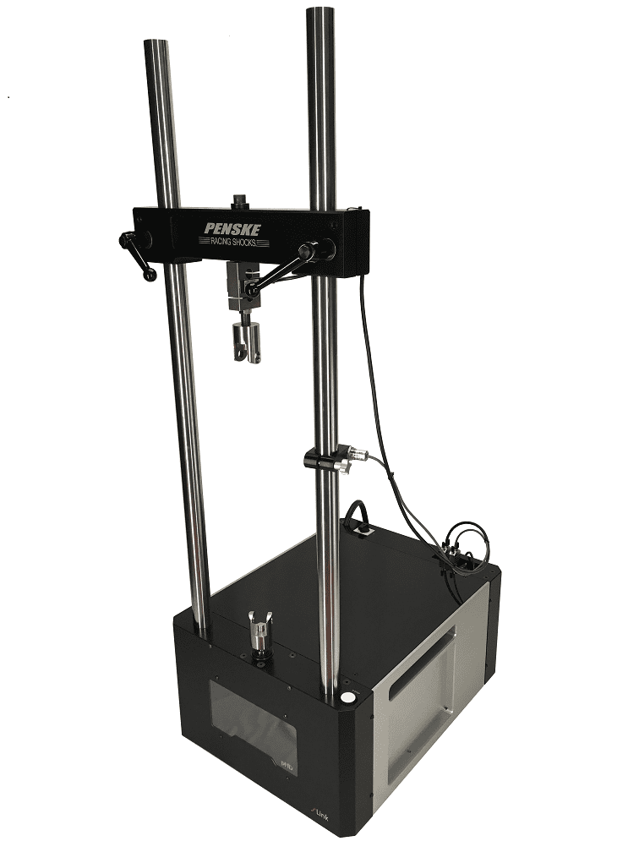

Figure : Penske S-Link PHD-2 Shock Dynamometer (Penske Racing Shocks, n.d.)

A shock dyno works by moving a racing damper through its range of motion while recording its velocity and force output. Typically, the damper is connected to a crank-slider mechanism which rotates at constant velocity, creating a sinusoidal motion. Because the dyno’s motion is created from a crank, the dyno must be paired with a damper of corresponding stroke length.

The main results yielding from dyno testing come in the form of Force vs Velocity plots as seen in Figure 3 and Figure 4. The graph is read by evaluating the force output of the compression and rebound stroke of the damper (Penske Racing Shocks, n.d.). Inward motion creates compression damping force on the positive axis of the graph, where outward motion induces rebound damping and negative force values. Figure 3 shows a simplified dataset which gives insight to the damping force at each speed. A more in depth dataset is found in Figure 4, where the acceleration and deceleration phase of each stroke can be seen. Unexpected results or large amounts of hysteresis can be the first signs of dampers needing maintenance or adjustments (Penske Racing Shocks, n.d.).

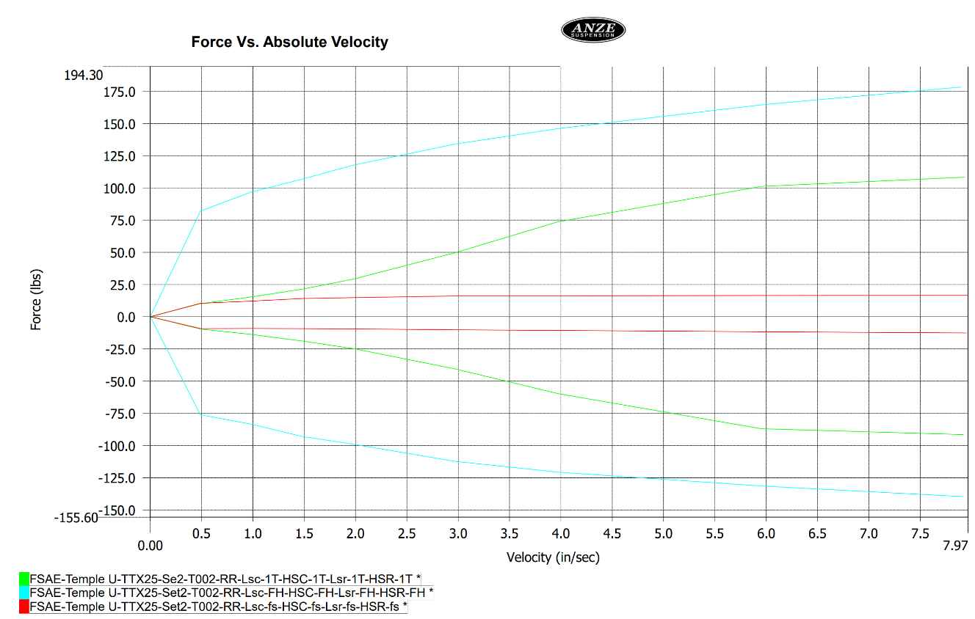

Figure : Shock dyno plot - Comparing damper adjustments (Courtesy of Temple Formula Racing)

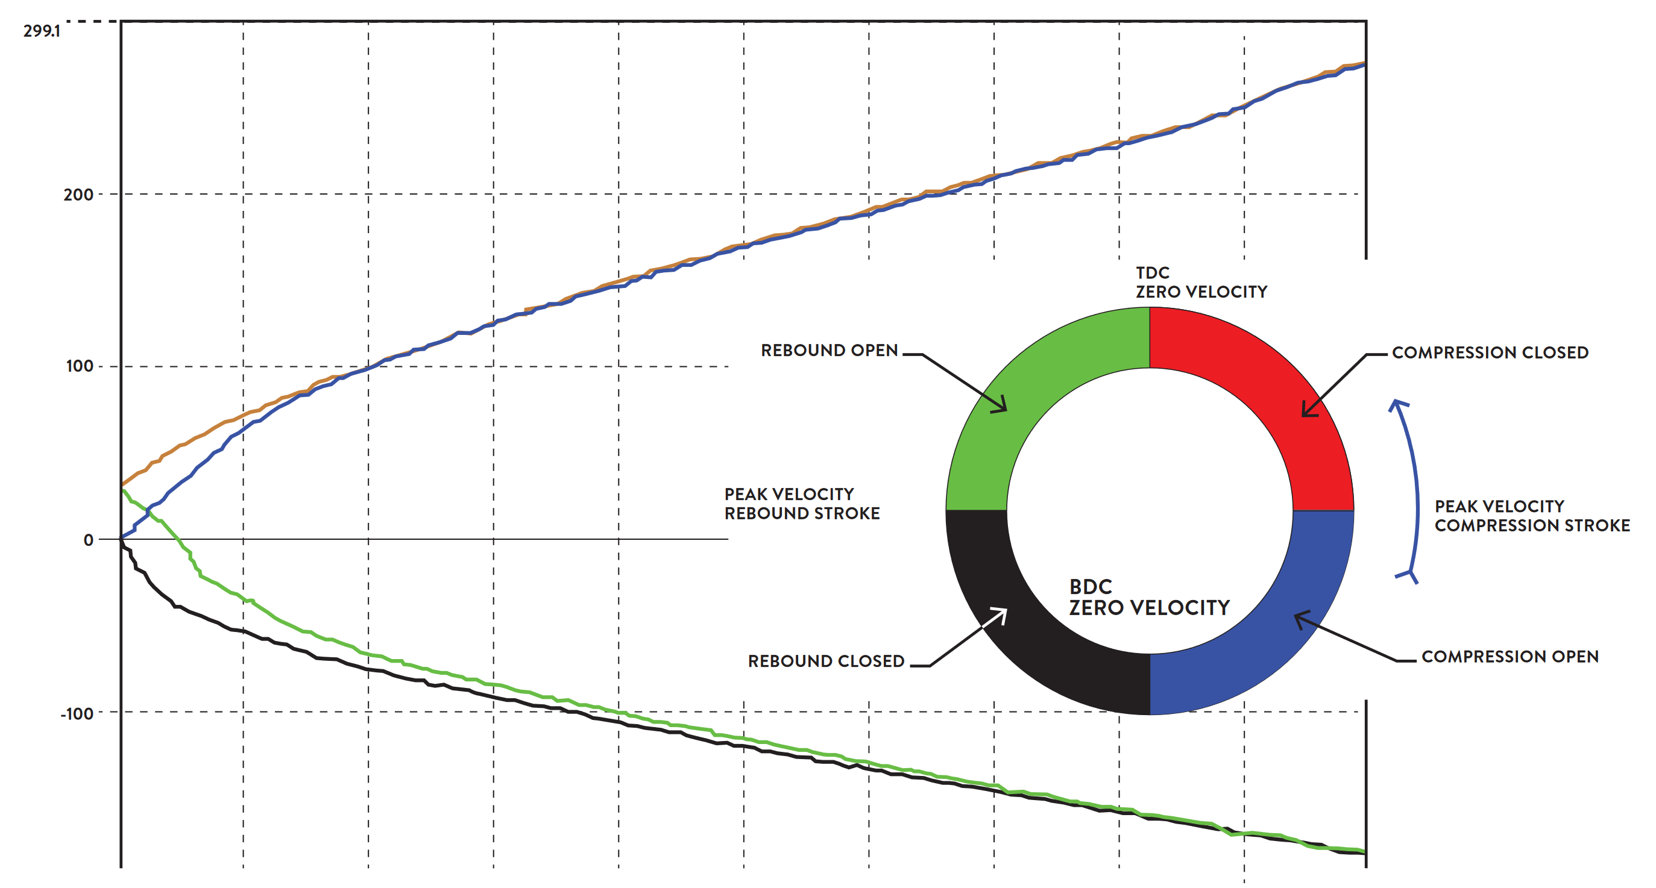

Figure : How to read a dyno plot (Penske Racing Shocks, n.d.)

Through analyzing the plot, an engineer can identify the force output at different damper velocities. Typically, the damper’s motion is broken into low and high speed motion; where low speed is the result of transient body motion during braking or cornering, and the latter coming from the feedback of road irregularities. Shock dyno plots become useful when comparing them to driver feedback or track data in particular parts of a lap. For example, if a driver suggests a lack of performance under braking, the engineer can determine that motion’s corresponding forces then use the shock dyno to verify changes in the specified region of damping.

Despite being a powerful tool, the main drawback to a shock dyno is that is focuses only on dampers. While making adjustments to dampers is a critically effective tuning method, it cannot address handling concerns related to core design elements of the vehicle.

### Full Vehicle Laboratory Testing

Dynamic vehicle testing was first introduced to the laboratory environment in the 1950’s, with a focus on overall vehicle comfort and durability (Dodds & Plummer, 2001). Early testing apparatuses were designed using two-stage servo-valves and four linear actuators or posts, which were concurrently being developed by the Moog engineering company (Dodds & Plummer, 2001). To operate the testing rig, a vehicle was suspended in the air in which an individual post supported each one of the vehicle’s wheels. The posts were actuated vertically in accordance to a testing cycle which aimed to statistically replicate a vehicle’s wheel travel (Dodds & Plummer, 2001). While subjective results reported good comfort, users noted potential error from the test setup lacking lateral and for/aft forces as well as inertial forces associated with rolling tires. Furthermore, some unresolved dynamics issue with hydraulics systems used throughout the 1960’s muddied the results from “excitement simulations” (Dodds & Plummer, 2001).

The next breakthrough in dynamic vehicle testing was “Response Simulation”. GM Truck and Bus conceived that by using a vehicle as the transducer, road inputs at the tire contact patch could be determined while driving at the proving grounds. The measured wheel response could then be used to drive closed loop control of the servo-hydraulic system (Dodds & Plummer, 2001). Implementing this system improved relevance of test results and lead to the creation of multiple testing software.

In order to increase accuracy of simulations, contemporary testing rigs have been configured to allow forces and motion in multiple directions. Triaxial systems have the ability to generate vertical, lateral, and longitudinal forces, and yaw and pitch moments at each wheel (Dodds & Plummer, 2001). These more complex setups allows analysis of vehicle characteristics such as self-aligning torque and braking, which would not be possible on previous four-post rigs. However, the setup for these tests are significantly more complex and require an extra actuator for every degree of motion (Dodds & Plummer, 2001).

An alternative method called “Body Restraint Testing” applies force and moment inputs through the chassis rather than wheels. The significance of this technique is that the inputs can be relatively small and output displacements in vertical, pitch, and roll can be large (Dodds & Plummer, 2001). Initial passive restraint setups were disadvantaged by changing the structural loading of the chassis, which skewed results. To eliminate this issue, later setups replaced fixed chassis restraints with actuators which could apply high frequency motions but respond to low frequency loads(Dodds & Plummer, 2001). These systems proved to have versatile control of the vehicle’s body and could introduce external forces such as aerodynamics in motorsports (Dodds & Plummer, 2001).

## Explanation of candidate solutions

### 4 Post Shaker Rig

The most simple form of full vehicle shaker discussed in this paper is the “4 Post Rig”. In this configuration, the racecar rests on four flat plates that are attached to vertical linear actuators. Figure 5 provides a simplified layout of a 4-post shaker rig. To perform tests, the four actuators are provided signals which move the wheel plates up and down. The resulting motion and forces coming from the vehicle are measured using a variety of sensors. A common setup involves mounting load cells and linear potentiometers on the actuators and mounting accelerometers at specific locations on the car.

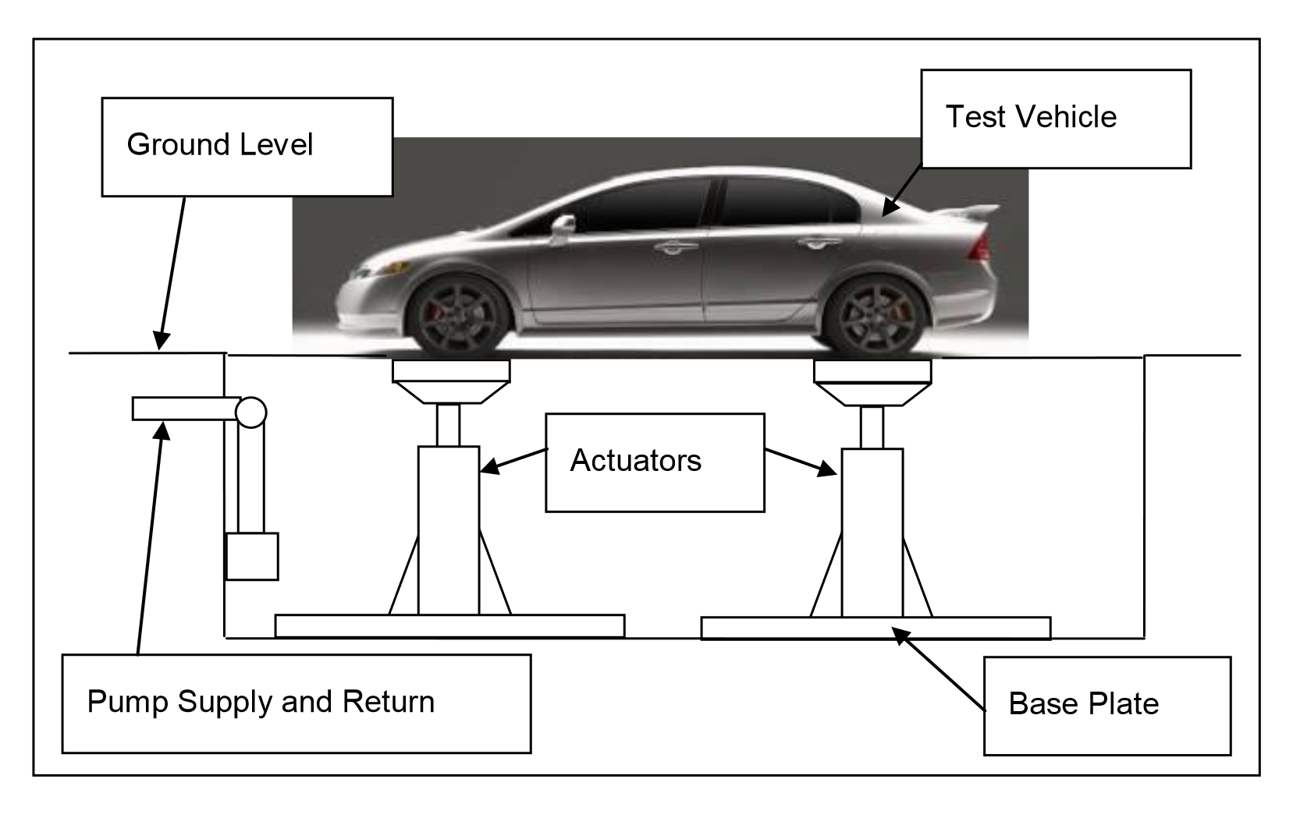

Figure : 4-Post Shaker Rig Layout (Bennett, 2012)

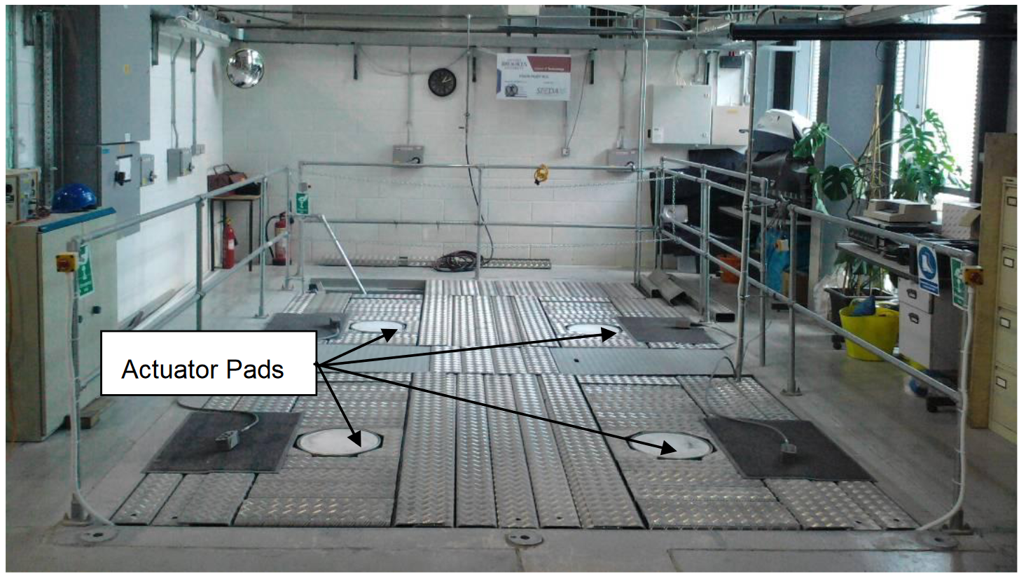

Figure : 4-Post Shaker Rig Top View (Bennett, 2012)

4-post shaker rigs are typically used to test a race car’s suspension in heave, pitch, roll, and torsion (Kelly et al., 2002).

A 4-post test was able to successfully gather data on chassis torsional stiffness, etc…

The main drawback to a 4-post rig is that aerodynamic affects found at higher speeds are near impossible to simulate.

### 7 Post Shaker Rig

A more capable and complex configuration of a full vehicle shaker rig is called the “7 Post Rig”. The extra three posts, often referred to as “aeroloaders” can be used to generate aerodynamic forces seen above roughly 100mph (“Seven-Post Rigs,” n.d.). The three aeroloaders are fastened to the chassis using custom brackets which must be made for each unique vehicle. Figure 7 shows an example of a 7-post rig with a formula car, where the aeroloaders are fastened to the front bulkhead and rear wing mount.

Unfortunately, aeroloaders have a tendency to dampen the vehicle’s natural response to road inputs by the wheel plates. To mitigate this, a compliant linkage can be arranged between the aeroloaders and chassis to allow loading with a sufficient amount of compliance to let the vehicle move unimpeded (“Seven-Post Rigs,” n.d.). This solution has its own issue, being that the added compliance does not allow the large downforce loads to be generated in the simulation. By using “velocity feed-forward” algorithms to predict the motion of the chassis in addition to a compliant link, a workable result emerges for downforce to be simulated on a seven post shaker rig (“Seven-Post Rigs,” n.d.).

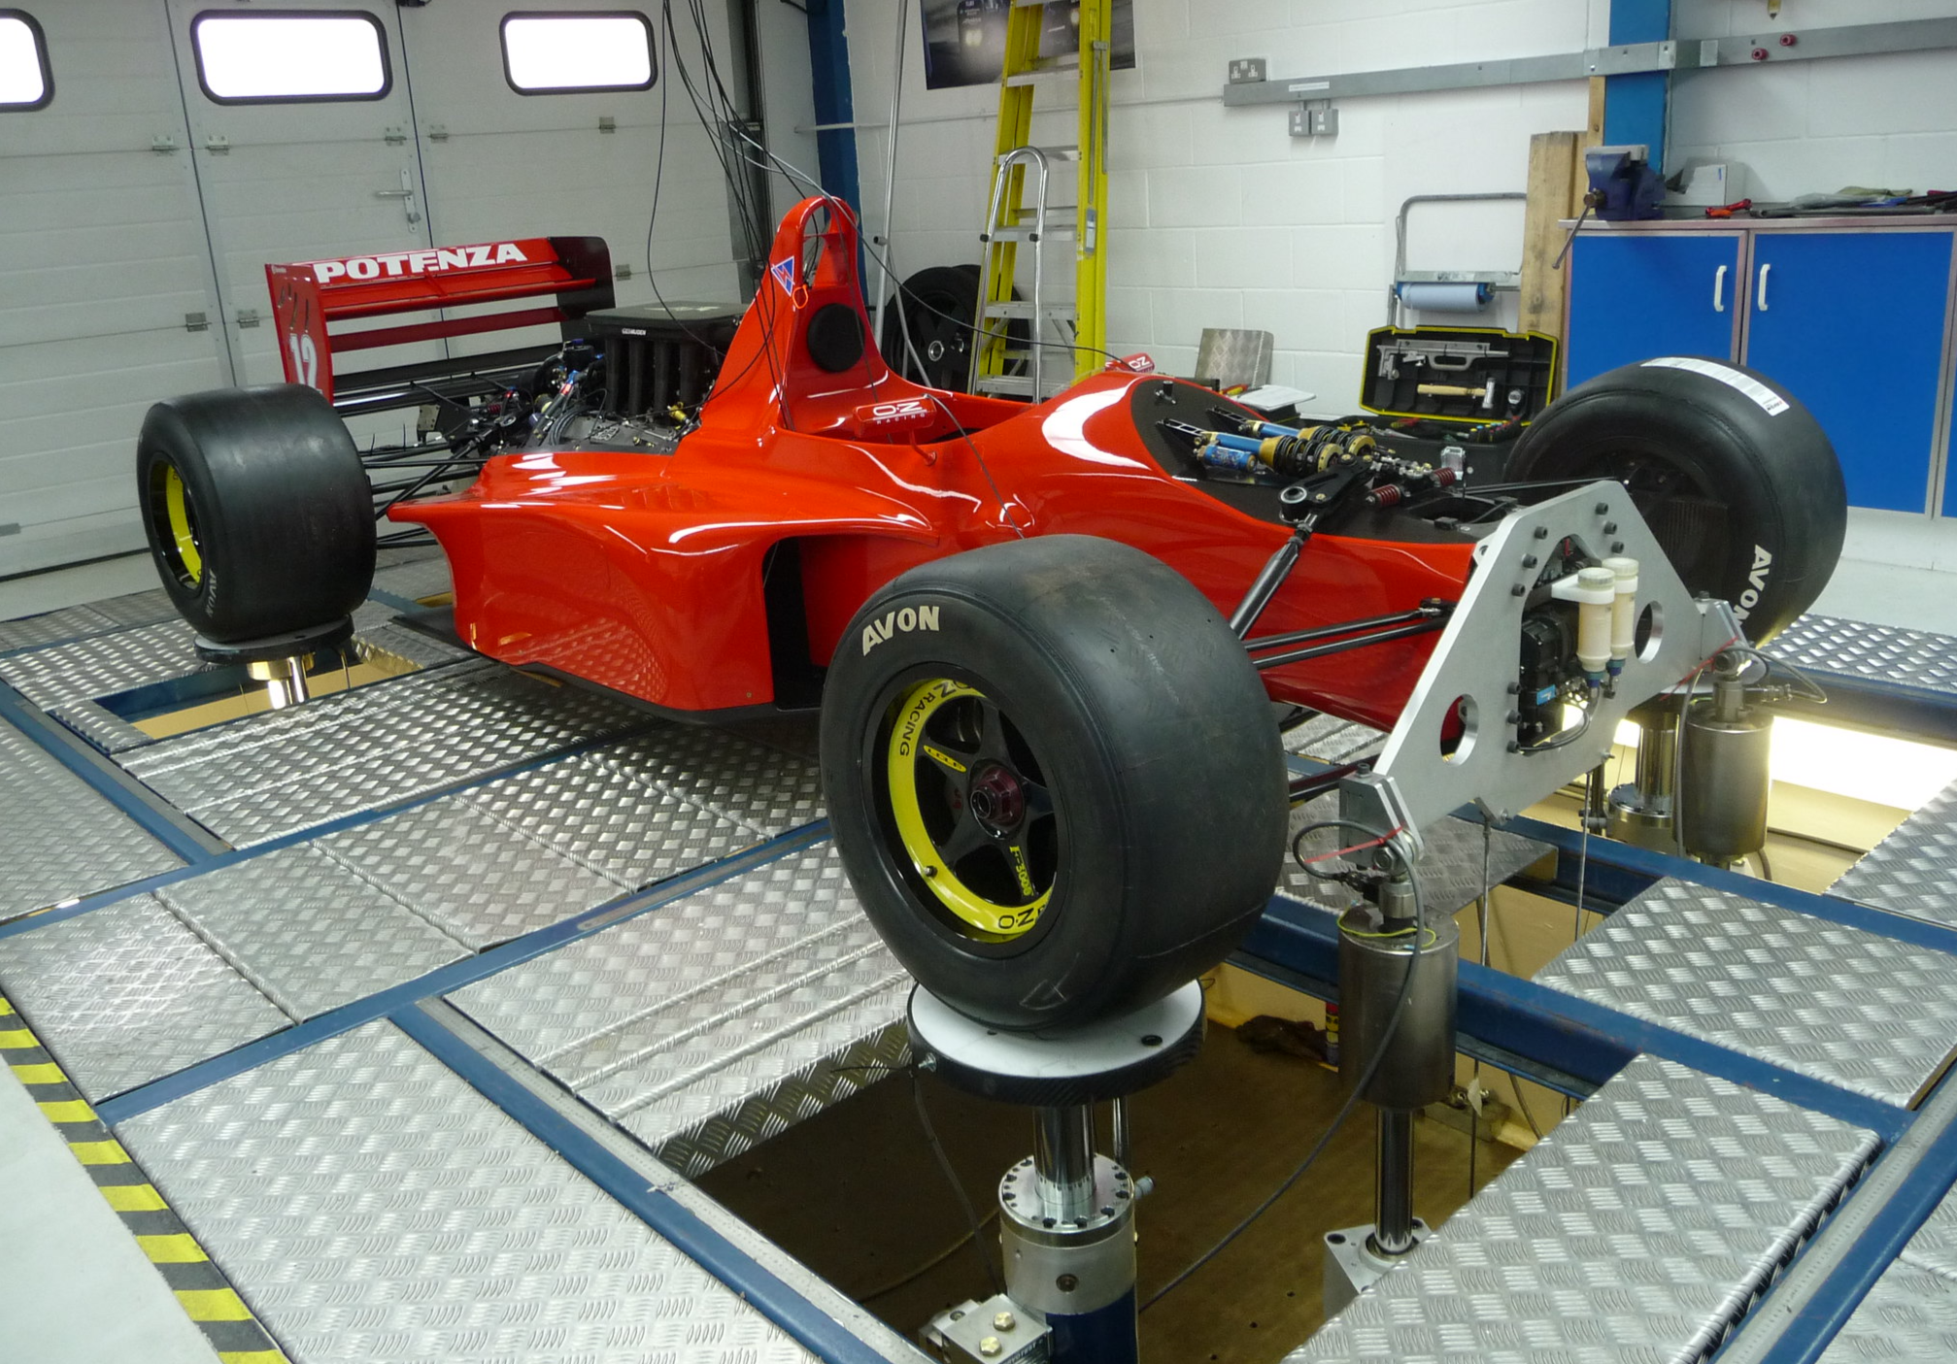

Figure : 7-Post Shaker Rig Setup

The general premise of 7-post performance analysis is similar to that of 4-post testing. Engineers will target setup changes that minimize variations in tire loading to maintain highest level of traction. With the addition of aerodynamic factors, more focus is placed on ride height control (Kelly et al., 2002). Since lower ride heights result in more downforce, optimized setups will be able to maintain consistent tire loadings while keeping the vehicle platform in an aerodynamically efficient position (Kelly et al., 2002). In Figure 8, a ride height vs time plot captured from 7-post testing shows the results of optimizing a set of front dampers. The resulting setup was able to run 1mm lower and had less variation; therefore producing more downforce and control (Kelly et al., 2002).

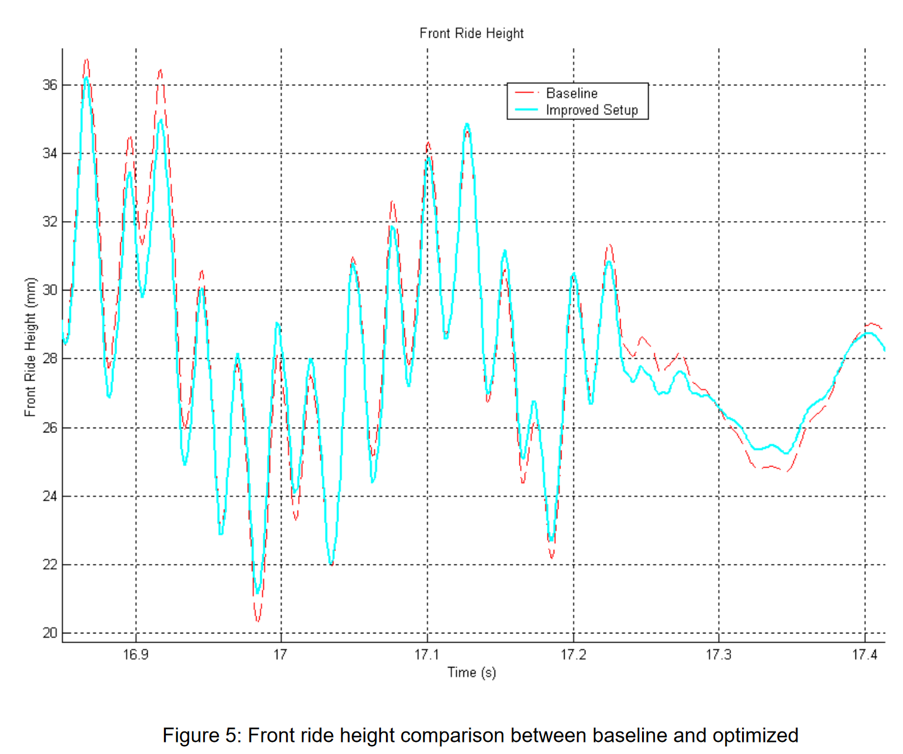

Figure : Front ride height comparison between baseline and optimized (Kelly et al., 2002)

### Kinematics and Compliance Testing

Kinematic and compliance testing, or K&C testing for short, is a laboratory method of analyzing the how suspension components of a race car move in relation to one another. This test is able to observe the kinematics that the real vehicle generates. This is important because inconsistencies during manufacturing process and damage from racing can mean the actual vehicles kinematic properties could differ from theoretical ones, resulting in poor performance. Also, this testing rig can empirically determine the kinematic properties of a vehicle without the need to geometrically define each component. The K&C testing apparatus can differ depending on the level of analysis, but typically involves suspending the vehicle with a number of actuators directly to each wheel assembly and some key locations on the chassis. Figure 8 shows one example of a K&C test rig in which there are vertical, longitudinal, and lateral motion input mechanisms for each wheel. Other configurations include one or multiple chassis mounted actuators to provide other testing conditions.

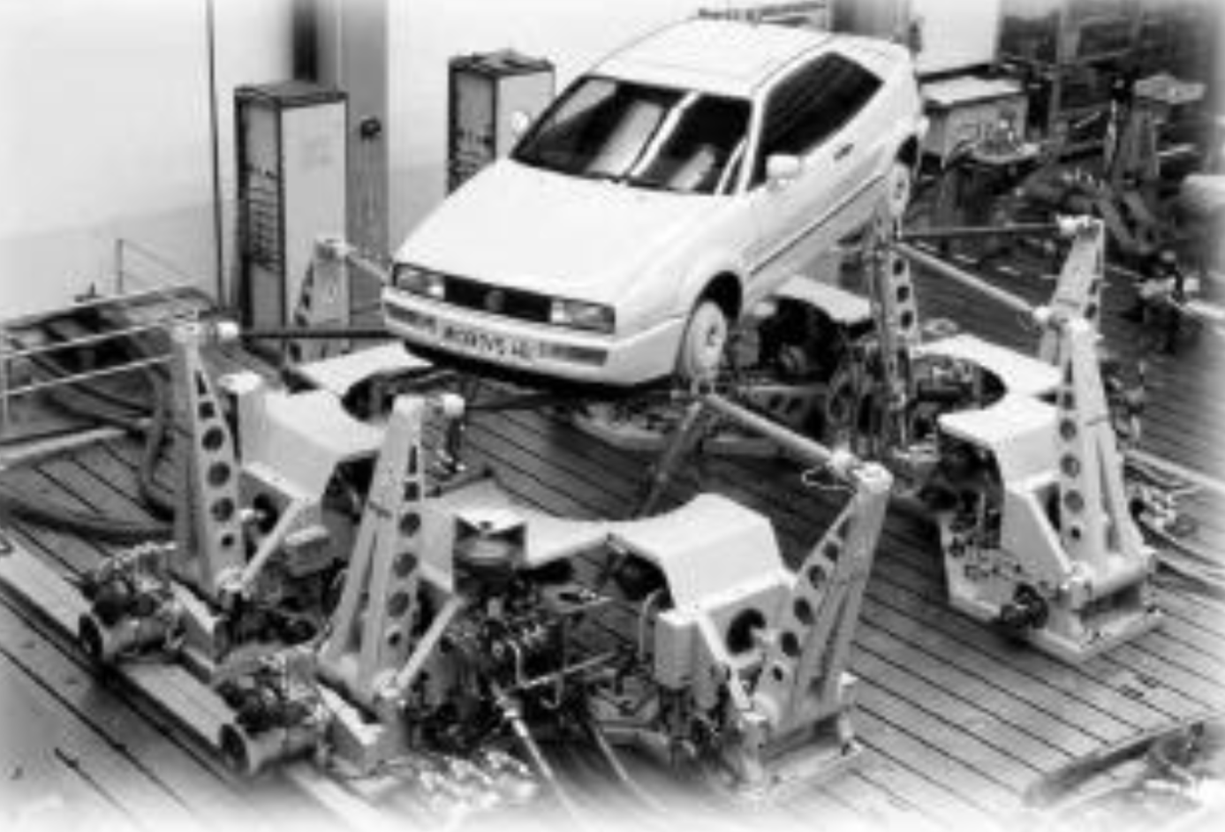

Figure : Kinematic testing simulator (Dodds & Plummer, 2001)

K&C testing can be broken into characterizing kinematics and defining compliance within the suspension system. K&C test rigs are able to provide suspension behavior data that helps engineers correlate track and subjective performance to kinematic and compliance characteristics (Best et al., 1997). It is possible to determine the sensitivity of vehicle characteristics to various suspension parameters. This means that a race car's "ideal" performance setup can be achieved while also determining a tolerance bandwidth (Best et al., 1997).

Work has been done to use K&C test rigs to validate theoretical kinematics results from ADAMS car (Zhang et al., 2023).

Morse Measurements explains that damper behavior needs to be calculated and added to simulations during tests.

Examples of K&C test results are shown in Figure 10 and Figure 11 where the front left wheel toe angle is analyzed. The first test demonstrates the use of K&C for kinematics characterization – where the tire position is related to transient body motion. The second test demonstrates characterizing the tire position in response to various component settings. Both tests are critical in determining whether the tire is operating in its ideal window.

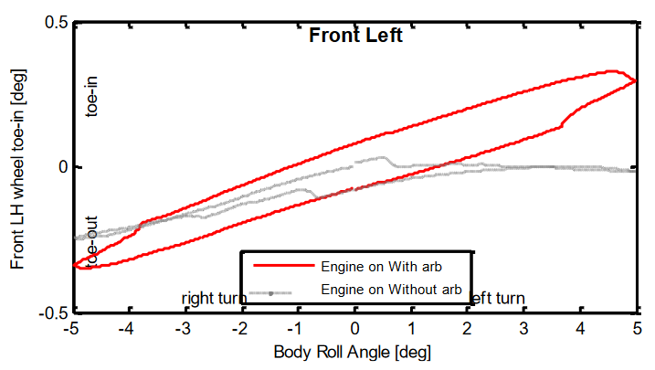

Figure 10: Influence of stabilizer bar on the change of tire’s toe angle (Jing et al., 2017)

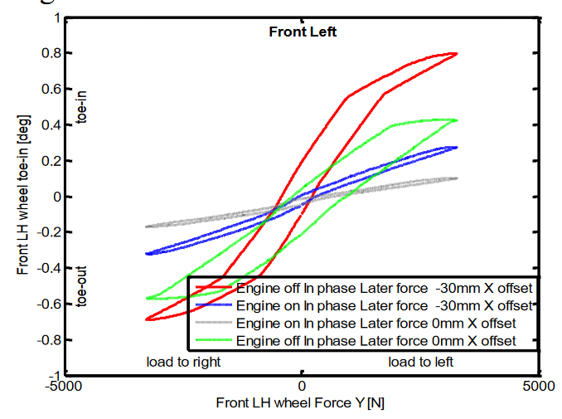

Figure : The effect of different settings on the toe angle of the suspension (Jing et al., 2017)

## Comparative assessment of candidate solutions

Table : Comparison of Candidate Solutions

|  |  |  |  |
| --- | --- | --- | --- |
|  | **4 Post Rig** | **7 Post Rig** | **K&C Testing** |
| Required Testing Rig Preparation | Adjust wheel plate locations | Adjust wheel plate locations, requires compliant link and feedforward algorithm, custom brackets for different vehicles | Adjust wheel assembly mount locations |
| Rig Data Channels | * 4x wheel actuator displacement * 4x wheel contact load * 4x wheel actuator acceleration | * 4x wheel actuator displacement * 4x wheel contact load * 4x wheel actuator acceleration * 3x chassis velocity transducer * 3x aeroloader displacement * 3x aeroloader load * Front ride height * Rear ride height * Air speed * Lateral acceleration * Longitudinal acceleration | * Suspension stiffness * Suspension friction * Ride stiffness * Roll stiffness * Tire radial stiffness * Toe angle * Camber angle * Geometric roll center * Longitudinal wheel center displacement * Longitudinal tire contact displacement * Steering transmission ratio * Steering friction * Kingpin caster angle * Kingpin inclination angle * Wheel hub flexibility * Toe angle kindliness * Camber angle kindliness * Tire contact stiffness * Anti-dive/squat |
| Required Vehicle Data Channels | * 4x hub accelerometers * 4x chassis accelerometers * 4x damper displacements * 2x damper temperature * Vertical body acceleration * Lateral body acceleration * Longitudinal body acceleration | * 4x hub accelerometers * 4x chassis accelerometers * 4x damper displacements * 2x damper temperature * Vertical body acceleration * Lateral body acceleration * Longitudinal body acceleration |  |
| Simulation Modes | * Quasistatic tests * Track simulation for low downforce cars | * Quasistatic tests * Track simulation extended to high downforce cars | * Quasistatic tests * Generalized testing of expected forces and motions * NO damping |
| Testing Duration |  |  | Loading, testing, unloading of vehicle in **less than 2 days** |
| Major test results | * Wheel load distribution * Ride height variation analysis * Pitch sensitivity analysis * Torsional stiffness | * Wheel load distribution * Ride height variation analysis * Pitch sensitivity analysis * Torsional stiffness | * Vertical loading conditions, * Lateral loading conditions * Longitudinal loading conditions * Roll conditions * Steering conditions * Correction force conditions |

# Project Recommendations

## Proposed solution

The ideal solution for racing teams to improve setup package development must be time efficient and yield a variety of specific test results. The comparative assessment shown in Table 2 leads to the conclusion that the 7-Post Shaker Rig is the best solution for setup development because of its fast turnaround times and wide range of use cases.

A major strength of shaker rig testing is the ability to run simulations of real tracks.

Kinematics and compliance testing can provide critical vehicle information but is not able to replicate one to one scenarios in the way the shaker rig can.

4-post and 7-post shaker rigs are able to generate similar results. It is obvious that being able to generate aerodynamic forces gives an advantage to the 7-post rig. Even for low downforce racing series the ability to replicate subtle aerodynamic effects provides an extra layer of accuracy in the analysis.

While K&C testing allows users to characterize there vehicle’s suspension behavior to a component level, its inability to include damping leaves it vulnerable. Further development would need to be conducted to ensure a car’s platform control has been optimized.

## Design and implementation challenges

Simulating racetracks faces challenges regarding artificial damping.

## Anticipated project outcomes and impacts

# References

## Additional sources consulted

Bennett, L. J. (2012). Ride and Handling Assessment of Vehicles Using Four-post Rig Testing and Simulation. *Oxford Brookes University*.

Best, T., Neads, S. J., Whitehead, J. P., & Willows, I. R. (1997). *Design and Operation of a New Vehicle Suspension Kinematics and Compliance Facility*. 970096. https://doi.org/10.4271/970096

Boggs, C. M. (2009). *The Use of Simulation to Expedite Experimental Investigations of the Effect of High-Performance Shock Absorbers*. https://vtechworks.lib.vt.edu/handle/10919/26108

Dodds, C. J., & Plummer, A. R. (2001). *Laboratory Road Simulation for Full Vehicle Testing: A Review*. 2001-26–0047. https://doi.org/10.4271/2001-26-0047

G, V., & M, M. (2002). *Vehicle Suspension Characterisation By Using Road Simulation on a 4-Poster Test Rig*. 63–70.

Gelotte, E. (n.d.). *Develompment of software that can predict damper curves on shock absorbers*.

Jing, L., Wu, L., Li, X., & Zhang, Y. (2017). Study on kinematic and compliance test of suspension. *IOP Conference Series: Materials Science and Engineering*, *231*, 012186. https://doi.org/10.1088/1757-899X/231/1/012186

Kelly, J., Kowalczyk, H., & Oral, H. A. (2002). *Track Simulation and Vehicle Characterization with 7 Post Testing*. 2002-01–3307. https://doi.org/10.4271/2002-01-3307

Penske Racing Shocks. (n.d.). *How to Read a Shock Dyno Graph*.

Segers, J. (2014). *Analysis Techniques for Racecar Data Acquisition—Second Edition*. SAE International. https://doi.org/10.4271/R-408

Seven-post Rigs. (n.d.). *Racecar Engineering*.

Smith, C. (1978). *Tune to Win*.

Zhang, H., Feng, G., Wang, H., Gu, F., & Sinha, J. K. (Eds.). (2023). *Proceedings of IncoME-VI and TEPEN 2021: Performance Engineering and Maintenance Engineering* (Vol. 117). Springer International Publishing. https://doi.org/10.1007/978-3-030-99075-6